horizontal line

**EE208:CONTROL ENGINEERING LAB 11**

**Nonlinear System dynamics on Simulink for different Lyapunov control designs**

**Course Instructor : Dr. Sanjay Roy**

**Date : 10th April 2022**



**Group Number - 14**

**Raj Kumar Deb 2020eeb1025**

**Tushar Sharma 2020eeb1325**

**Tiya Jain 2020eeb1213**

# 

## TABLE OF CONTENTS

**1. OBJECTIVE** **3**

**2. GIVEN INFORMATION** **3**

**3. REFERENCES FROM LAB 08 & LAB 10** **4**

**4. APPROACH** **5**

**5. SIMULINK SIMULATION** **6**

5.1 A brief description  7

5.2 Selection of best possible Input 7

**6. OBSERVATIONS** **8**

Case 1: Oscillatory Nature 8

Case 2: Lagging Nature 10

**7. CONCLUSION** **17**

# 

# 

# 

# 

# 

# 

# 

# 

# 

# 1. OBJECTIVE

Dynamic studies of the crane trolley system introduced in Expt. #8 and #10, with which different Lyapunov control designs are to be incorporated.

The systems are to be individually simulated on Simulink; each using a detailed nonlinear state space system simulation in four state variables.

# 2. GIVEN INFORMATION

* Differential equation of a simplified model of an overhead crane:
* Parameters :
  + Arbitrary :
  + Constant:
* Variables :
  + Input:
    - u: Force in Newtons, applied to the trolley.
  + Output:
    - y: Position of load in metres, . y(t) = x1(t) + l . sin x3(t)
  + States:
    - x1: Position of trolley in metres.
    - x2: Speed of trolley in m/s.
    - x3: Rope angle in rad/s.
    - x4: Angular speed of rope in rad/s
* The given Lyapunov functions are:

1)Proportionate to square of linear potential energy: =

2)Proportionate to linear kinetic energy: =

3)Proportionate to square of rotary potential energy: =

4)Proportionate to rotary kinetic energy: =

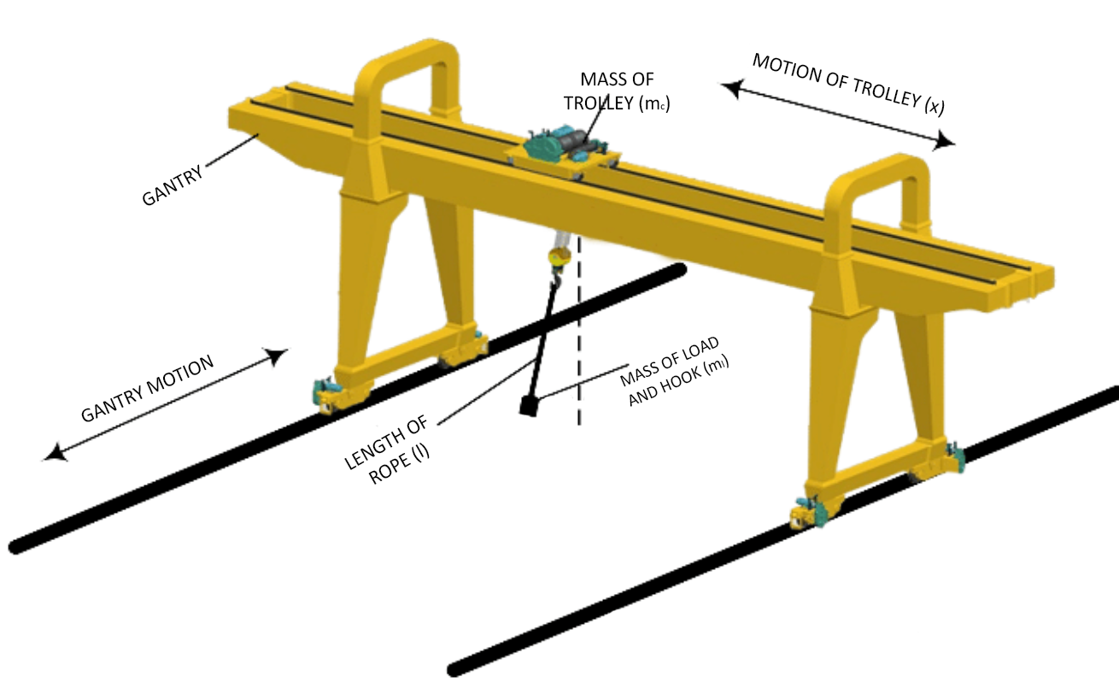

Figure 3.1 Overhead Crane

# 

# 3. REFERENCES FROM LAB 08 & LAB 10

* At any point of time, the system is completely described by the given four states .
* From given definitions of x1 and x2, we can infer that .
* The only input ‘u’ is the force applied to the trolley(in horizontal direction and hence affects the rate of change of speed i.e. x2’).

And the output position is given by y(t) = x1(t) + l.sin(x3(t))

* From the observations of experiment #8, we concluded that the state variables at equilibrium points were of the form [x1 0 n*𝝅 0]T and further analysis at these points revealed that the system is highly unstable at points of the form [x1 0 𝝅 0]T which is identical to all values of x3 as odd multiples of 𝝅, and remains marginally stable (only for the ideal case neglecting any friction) for points of the form which is identical to all values with even multiples of 𝝅 and with the input force as ‘0’.
* The input value of force as zero here is understandable as with non zero value of force, the trolley will keep on accelerating and hence x2’ and x1’(i.e. x2) cannot be ‘0’, which is a requisite for linearisation (derivatives of state variables). Similar is the case here with nonlinear systems : When we apply a non zero force (step and ramp), then the value of speed changes and hence distance keeps on increasing, so we need to apply brakes (in other words, a force of same magnitude and opposite direction to reduce the speed to 0 again and hence restrict further movement of the trolley once positioned in its desired location.
* From Experiment #10 , we observed that the states obtained were showing oscillatory nature. Therefore we needed to make our system stable, this could be achieved only when there were no oscillations. To do this we will analyse the Lyapunov functions and give feedback to the system accordingly.

# 

# 4. APPROACH

STEP 1: Using the bang-bang input we saw that the states moved towards oscillatory behaviour and the oscillations were bounded.

STEP 2 : The system is made to have a lagging nature

STEP 3 : The stabilised system from the last experiment is further worked upon and best possible linear combination of lyapunov functions were taken into consideration

STEP 4: We later determined the values of K-constants of given Lyapunov functions to us in the experiment.

# 

# 

# 

# 

# 

# 5. SIMULINK SIMULATION

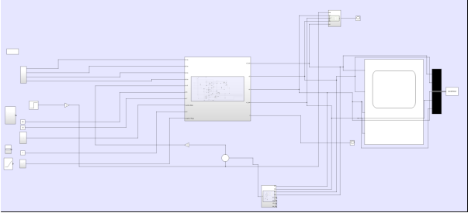

## 5.1 A brief description :

From the equations given to us :

We began with the blocks for the input segment which helped us create the different types of inputs and provide initial conditions to the states. The input block, block representing different equations , scope module etc we made the basic framework simulation of the crane.

###### **Comments : We were precautious while picking up input values as we change parameters like step time, final time and initial time according to our needs.

###### We also worked with different magnitudes of particular kind of input forces (step, impulse and ramp) with the help of additional gain block K in our Simulink model

###### **Notes :

###### We used the integrator blocks instead of the derivative block since we generally avoid using derivative blocks as they consume more power compared to integrators.

## 

## 5.2 Selection of best possible Input

* In the previous experiment, we have utilised the fact that to stop the crane at a particular position (x1), we need to apply an equal and opposite force (as compared to the one given while starting the crane) in such a manner that the crane’s velocity reduces to zero exactly at the desired point. Otherwise it would keep on moving (as observed for step, impulse and ramp inputs). So, we applied a bang-bang input in order to achieve this goal.
* But in this experiment, we try to design a controller such that we don't need to take care of the net input force equating to zero that too under time constraint so as to reach and more importantly stop exactly wherever desired. The basic idea of approach is that once we apply an input force, our control system itself works on it, reducing its speed gradually as it approaches our desired equilibrium location.
* Thus we modify our previously designed open-loop control system to a closed-loop system by introducing a feedback loop. Now since the main principle of working of a closed loop system is to reduce the error term (magnitude of difference between reference and output) to zero as time progresses, these systems have a tendency to show oscillatory behaviour.
* As it is more preferred to have a lag response (which rises gradually and settles at a steady value once reached there), we also introduced an extra PID controller in cascade. So, our controller is expected to run on a given input (ramp, unit or impulse), mobilise the trolley towards the desired location, gradually reduce the speed finally to zero as we reach there, and keep the overall response to be of lag type rather than an oscillatory one.

# 

# 

# 6. OBSERVATIONS

## Case 1: Oscillatory Nature

In an open-loop system, the states show an oscillatory behaviour for the provided bang bang input. We can see that the states tend to be oscillating with no decay but are nonetheless bounded. This kind of mechanism will eventually harm the crane with repetitive operations.

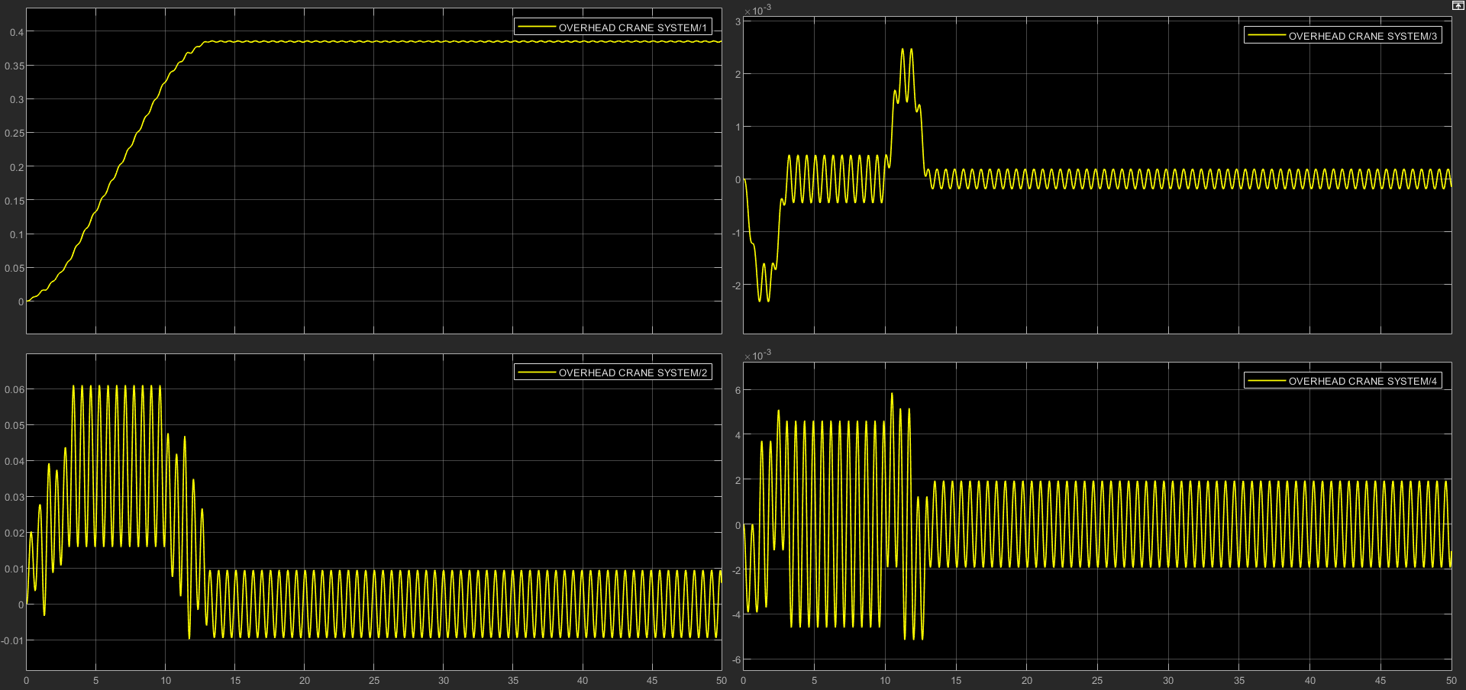

###### Figure 8: Oscillatory nature of states for loading mass 500kg

Further analysing the Lyapunov functions given to us for the oscillatory type dynamics, we observe the following graphs

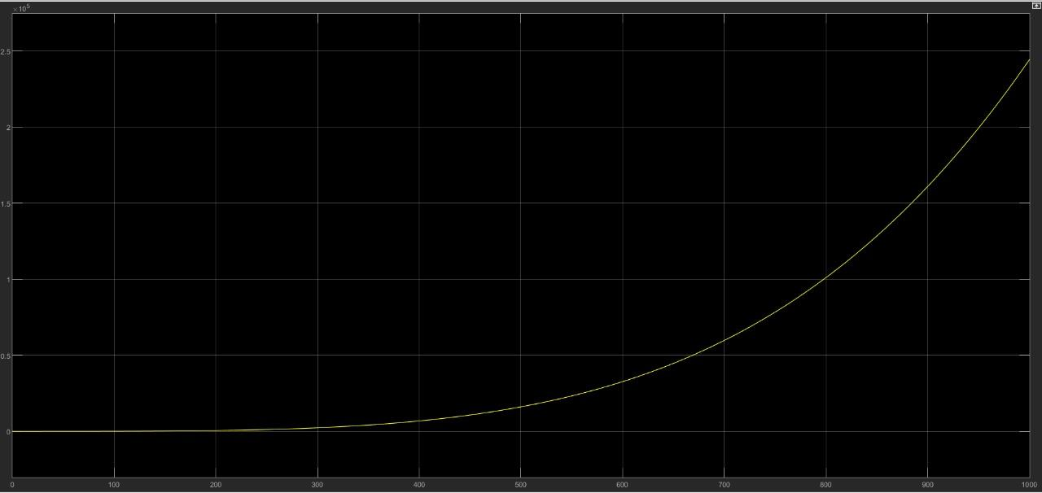

*Figure 9: The graph depicting the energy for the complete combination of Lyapunov Functions*

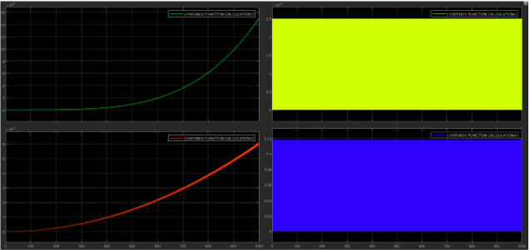

###### Figure 9: Energy of individual states.

In the above Figure 9, the individual Lyapunov function represents the above energy states.

## 

## Analysis :

* The energies of states x1 and x3 are seen to be increasing exponentially along with small oscillation and the energies of states x2 and x4 are seen to be oscillating about a positive value.
* The uncontrolled increasing nature of energy will result in increasing the potential energy of the trolley and the rotational energy of the load. This behaviour eventually leads the system towards instability

## 

## 

## 

## 

## 

## 

## 

## Case 2: Lagging Nature

We placed a PID controller to the existing differential equation solver in the position of cascaded form. The below graph represents the laggy nature of response :

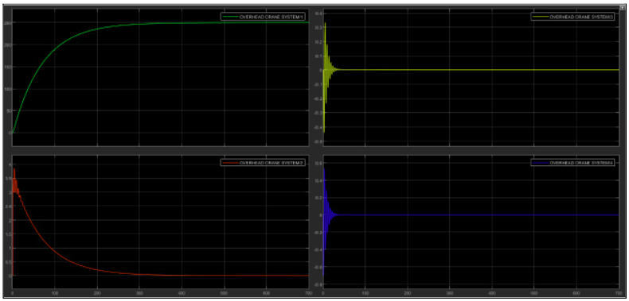

###### Figure 10: Nature of states under lagging type dynamics for loading mass 500kg

## Observations :

1. Initially, the velocity of the system (x2) increases momentarily on applying an input force. Then it starts to reduce and finally settles to zero before the reference point is reached.
2. The best part about this control is that it stops exactly at the desired location (the reference distance). This depicts the accuracy of the simulated control.
3. The angle(x3) and the angular velocity(x4) increase initially when the force is applied, then it starts reducing, finally settling to a value of zero again as we reach the reference position.

## 

## 

## 

## Analysis :

* With the use of a feedback path, the efficiency of our controller has improved. Now, once we set the reference position and just apply the input force, the controller itself works on it and stops the crane exactly at the desired location.
* The variation of the state x1 now shows a lag type behaviour, that is it changes gradually from the initial location of the crane to the reference location and then settles there(no overshoot at all). Hence, the trolley does not move beyond the reference position once reached, it only travels the distance between the initial and final positions.

## 

## 

## Lyapunov Function Calculation :

Here, we are supposed to formulate the overall Lyapunov Function as a linear combination of –

Now, for any combination of these terms the Lyapunov function will be greater than or equal to zero. So preferring global minimum, the whole function equates to zero, when , , , . So we have the equilibrium points of the form , as was obtained in experiment #8 by linearization of the system equations, only that it was found to be a point of marginal stability(for open-loop analysis).

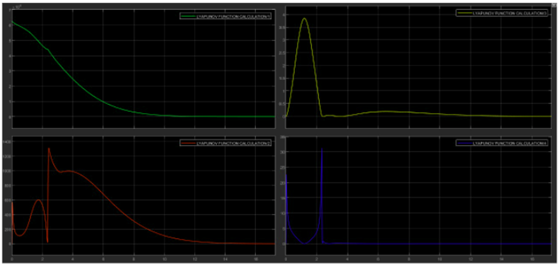

*Figure 11: Individual Energy Functions A,B,C,D*

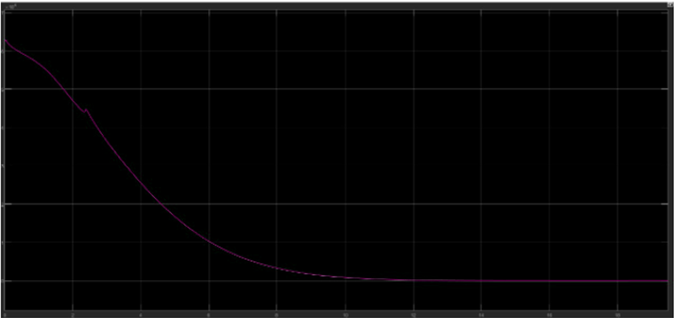

###### Figure 12: Net Energy Function (A + B + C + D)

# Now as the trolley is supposed to move from one position to another, along with carrying the load mass to be shifted, the energy element A (Proportionate to *square of linear potential energy*) is inevitable.

* Further, a reasonable choice of the velocity(x2) also matters, as extremely high speeds of the trolley is not at all acceptable due to safety reasons (for people working nearby and also for proper working of the crane itself). Neither is very low speed preferable since one would not like to wait for very long in order for a bulk of mass to be shifted from one position to another. Thus, a reasonable magnitude of B (Proportionate to *linear kinetic energy*) is also expected.
* Further, regarding choice of C and D, it is more favourable for us to reduce the oscillations of the mass to as close to zero as possible, so that it does not keep on oscillating for a long time once the crane reaches the desired position of x1. Hence contribution to the total energy function due to these components C and D should be negligible when compared to A and B.
* All these desirable trends have been observed (the crane reaches its reference position in quite a good time, i.e. energy components A and B are significant, whereas C and D values are quite low as x3 and x4 settles to zero quickly).
* Thus, a good Lyapunov function can be derived as

## 

## 

## 

## 

## 

## 

## 

## 

## 

## Effect of variation of mass on total energy *(A + B + C + D)* :

1. **For load mass, mL = 250 kg.**

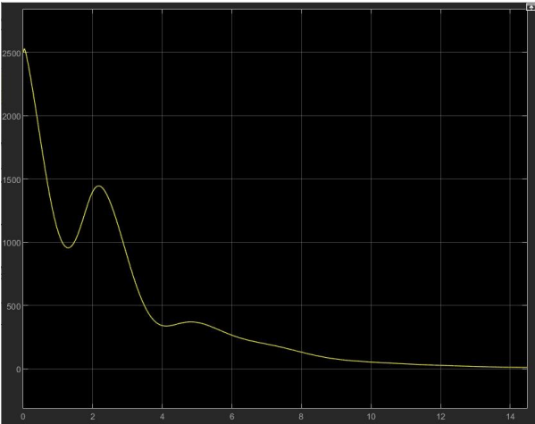

1. **For load mass, mL = 500 kg.**

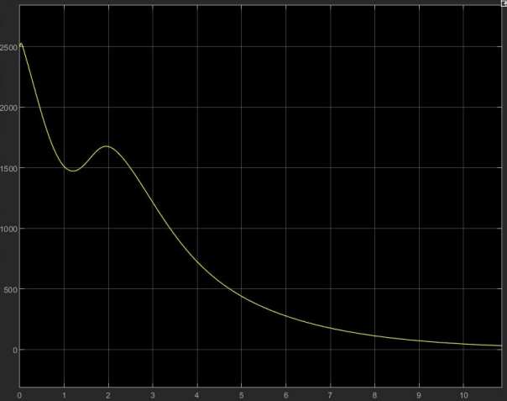

1. **For load mass, mL = 1000 kg.**

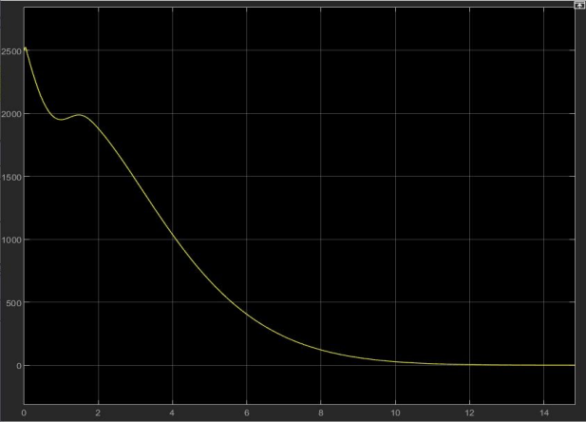

* On increasing the value of load mass (mL), it is observed that the total energy falls to zero at a quicker rate, i.e. the time of decaying of energy to zero reduces.
* This trend is in fact expected since when we increase the load of mass to be carried for a given amount of input force it is obvious that the energy would fall more quickly as there is demand for more effort.

# 

# 

# 

# 

# 

# 7. CONCLUSION

* In continuation to our observations in experiments #8 and #10, we introduced a feedback loop in order to stabilise our response and also attached a PID controller in cascade in order to remove oscillations and get a smooth lag type response.
* Further, using Lyapunov analysis it was found that the equilibrium point (with minimum energy, i.e. zero) is which is consistent with our conclusions from experiment #8.
* A good Lyapunov function is further formulated to be mainly dependent on A and B energy components mostly.

* Further increase in load mass shows lesser time of decay of total energy.